LI832 YA Review Blog
Dawn Brumbley
(Compiled semester-long)

Anatomy of a Boyfriend by Daria Snadowsky

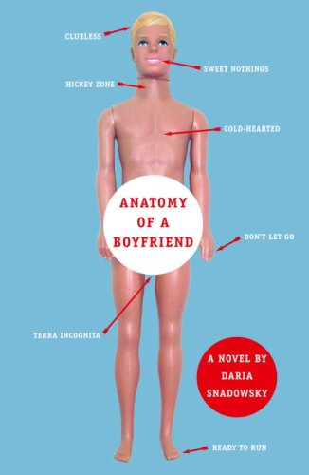

Snadowsky, D. (2007). Anatomy of a boyfriend. New York: Random House Inc.

This book fits best for high school students, ages about 14-18, Grades 9 and up, depending on maturity level. There is a lot of sexual content that might not be appropriate for younger readers.

The genre would be contemporary realistic fiction (also: teen romance, even though I hesitate to call it a romance.) This book definitely deals with real-life issues that teens face daily.

This book is told from the perspective of Dom, or Dominique Baylor, who is in her senior year of high school. It starts in the middle of the year, during Christmas break, and it focuses on when she meets Wes Gerswhin and the relationship that develops over the entire book with Wes. Her first boyfriend. Dom has an outspoken best friend named Amy, and two loving parents who are a teacher and a police officer. She faces the challenges of preparing for college, dealing with her changing relationship with her parents, trying to understand herself both physically and emotionally, and going from first kiss to losing her virginity. It’s an emotional ride.

Themes: Dating, sex, high school, family dynamics, self-understanding

Awards: None to date

My opinion- I loved this book. I relived my awkward experiences as a teen through Dom, and I remembered what it was like to have such high highs and such low lows that come with falling in love. She has to deal with understanding her parents, dealing with loss in several ways, and just trying to get through high school while attempting to understand herself. Some readers might find it graphic, but I felt as though it was a very good book and worth reading not only for the nostalgia, but to be reminded about the vulnerabilities of simply being human.

Divergent by Veronica Roth

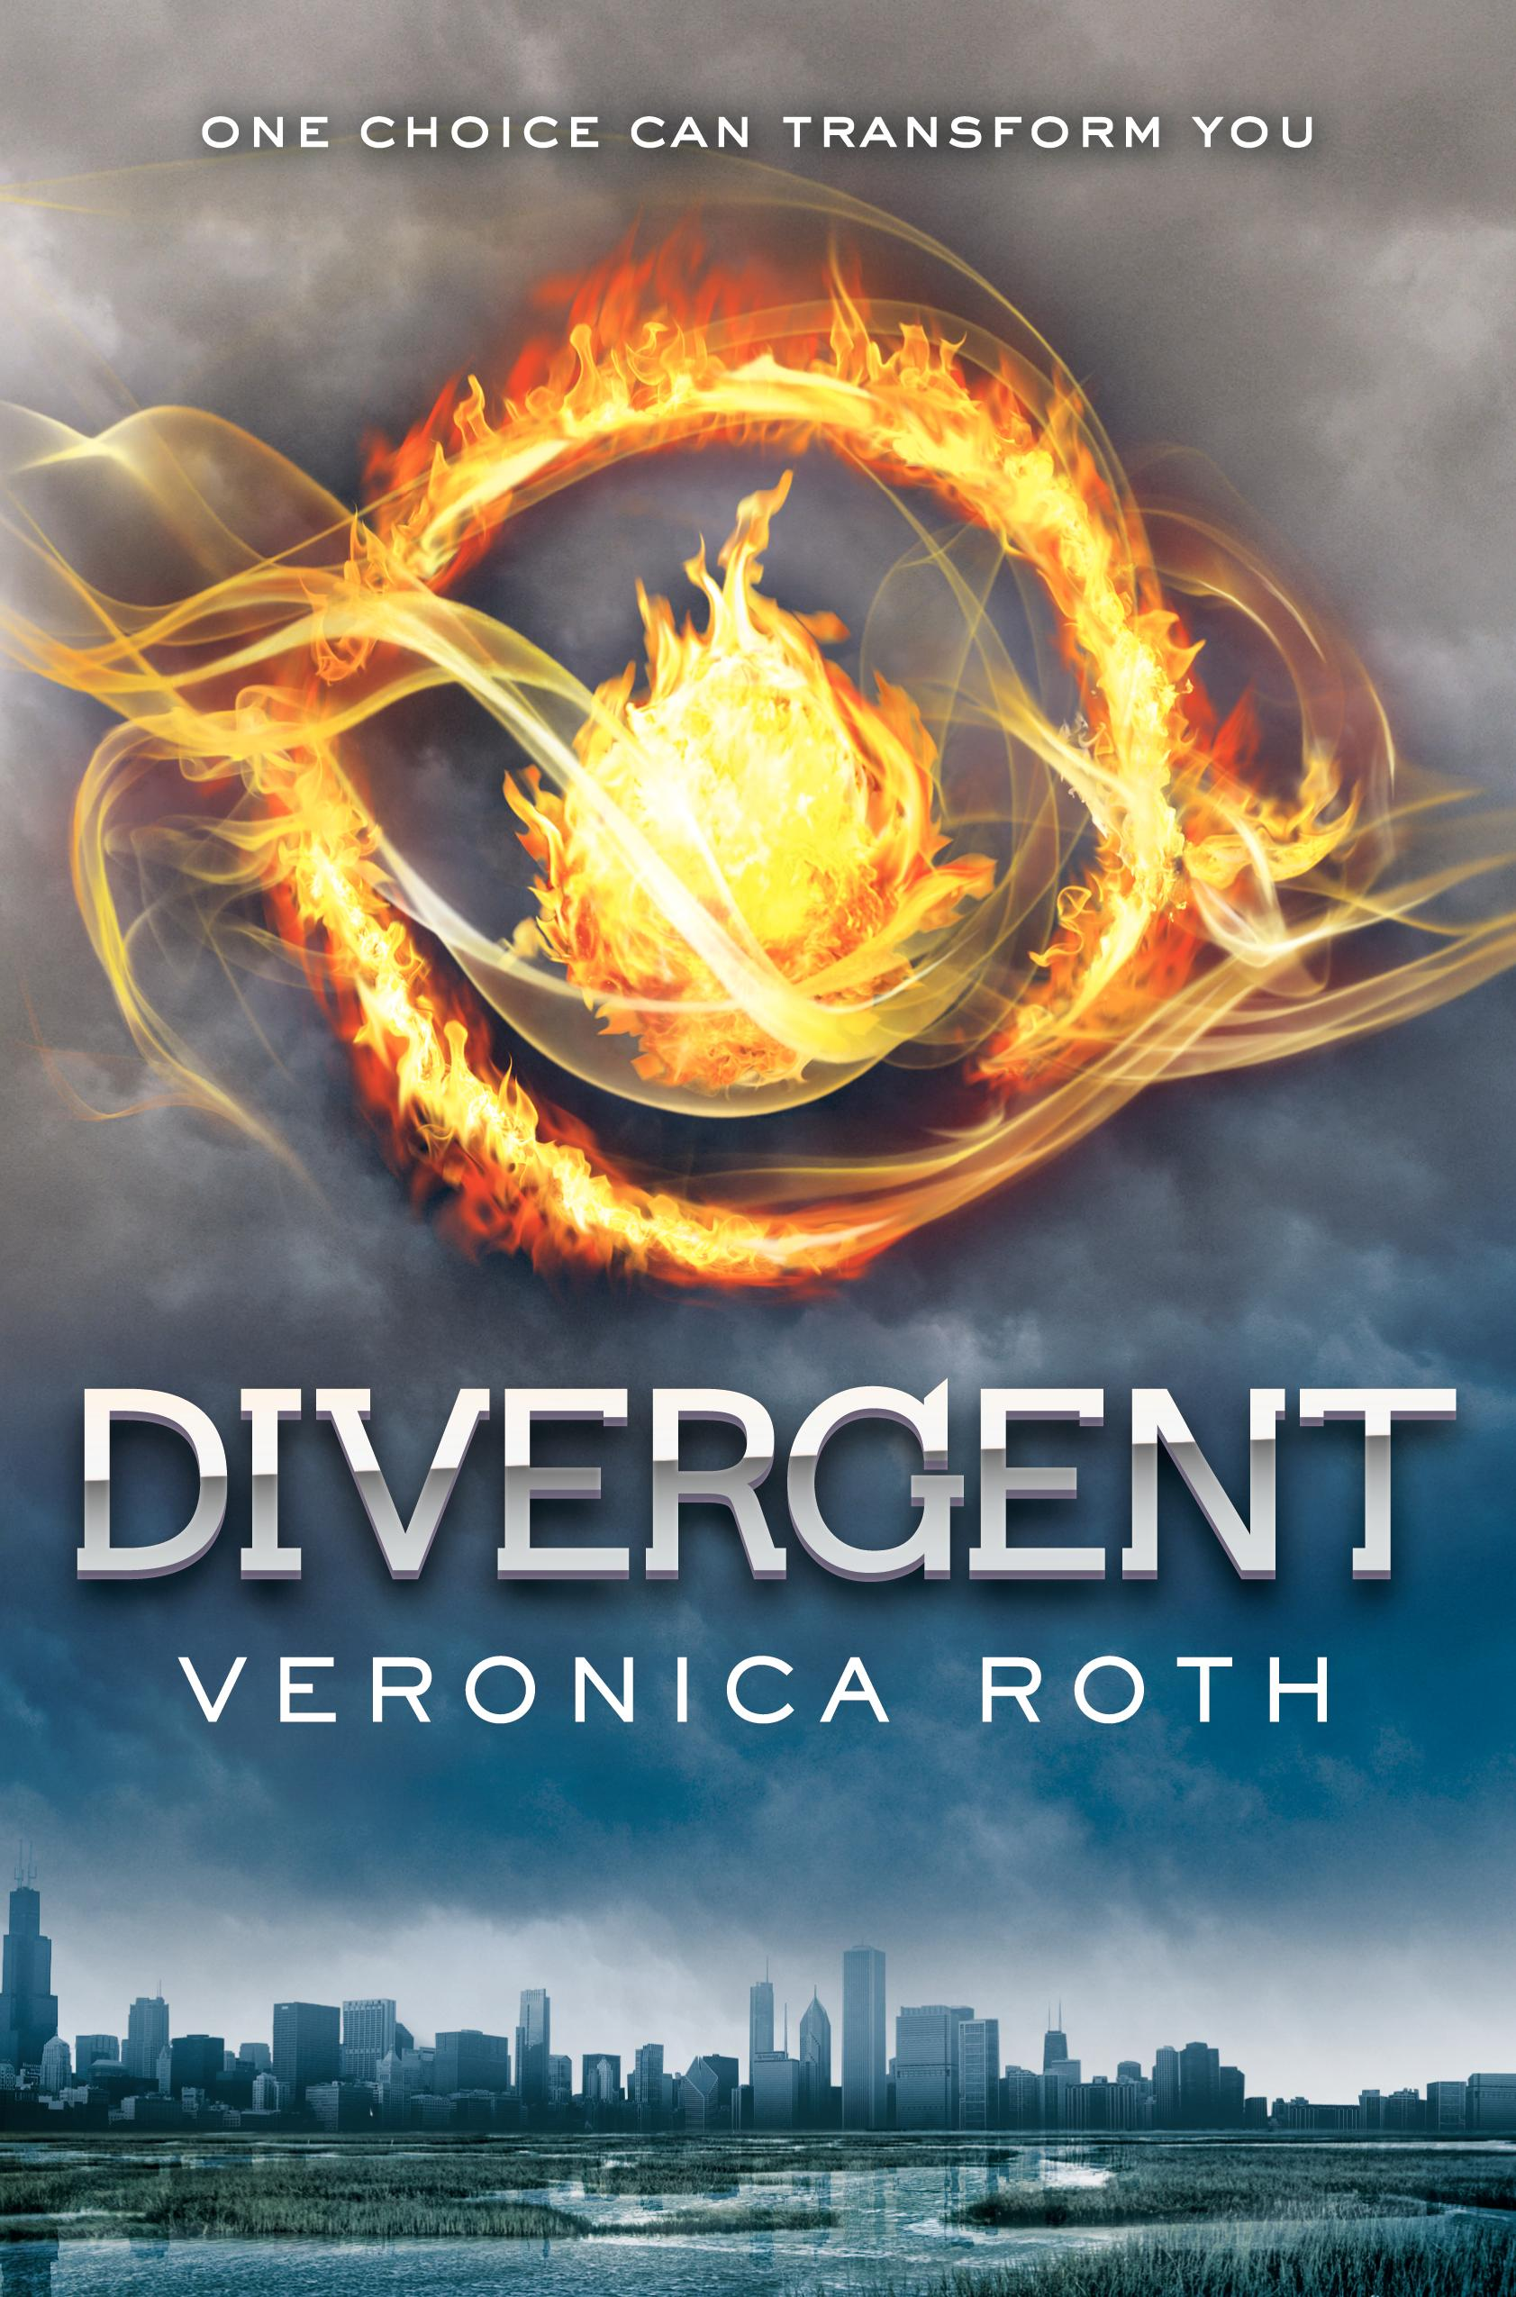

Roth, V. (2011). Divergent. New York: Katherine Tegen Books.

This book is a good fit for ages 13 and up, grades 7 and up. There are mild references to sex and intimacy, and a lot of violence.

The genre for this book is science fiction, subgenre is dystopian.

This book is told from the perspective of Beatrice, or Tris, in a dystopian version of Chicago. It takes place just before she must decide which “faction” she will choose after turning 16. In this world after the America we know has been transformed, there are five factions in which people live, depending on what virtue they hold most important. Once Beatrice decides to leave her home faction to join another, a whole new world opens up for her, much more dangerous than she’s ever known.

Themes: family, community, self-improvement and growth, independence

Awards:

- Favorite book of 2011 in 2011's Goodreads Choice Awards.
- Number one in the Teens' Top Ten Vote, sponsored by YALSA.

My opinon-

Another book that I would highly recommend! What a beautiful, emotional novel that forces the reader to think deeply about a lot of things. The reader is forced to think about what they value most (what faction they would fit into) all the way to how they would survive dangerous situations and what the real meaning of family is. Roth does an amazing thing with understanding human nature, and I would recommend this to ANY reader, young or old!
Thirteen Reasons Why by Jay Asher

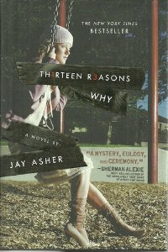

Asher, J. (2007). Thirteen reasons why. New York: Penguin Group.

A lot of reviews show this book to be fit for ages 12 and up, though I would recommend it to older readers, probably 14 and up.

Genre is probably general YA fiction, but I would go so far as to say contemporary realistic fiction.

This book is told from two perspectives, really, from Hannah’s perspective as she narrates the tapes for the people she considers are her “13 reasons” and from Clay’s perspective as one of the recipients of the tapes. The book goes through Hannah’s 13 reasons why she ended up committing suicide, and the reader spends a good portion of the book wondering why Clay even received the tapes in the first place. Though the book seems fairly straightforward, it’s difficult to read emotionally because Hannah is already dead by the time the book starts and so that’s a heavy burden to bear during the entire book.

Themes- Teen suicide, bullying, teen violence, teen substance abuse, high school
Awards-
- 2011 - Paperback edition became a #1 New York Times bestseller in the US
- 2010 - Georgia Peach Book Awards for Teen Readers
- 2009 - International Reading Association Young Adults' Choice list
- 2008 - Best Books for Young Adults YALSA
- 2008 - Quick Picks for Reluctant Young Adult Readers YALSA
- 2008 - Selected Audiobooks for Young Adults YALSA
- 2008 - California Book Award winner - Young Adult

My opinion- Any book about suicide is going to be hard to read, but it’s especially difficult to read from the perspectives of both the person who kills herself and the boy who liked her. At the end of the book I found myself wishing (as Clay does) that somewhere along the way someone would have made different choices. I also don’t completely sympathize with Hannah as a victim, which I believe was Jay Asher’s point. She made a decision far in advance, far enough to make the tapes, and a part of you as the reader has to think that the tapes are partly in revenge for the pain the people caused. Not simply because she feels they need to feel responsible. It’s a worthwhile read, but definitely not light reading or easy reading by any means. However, it could really help someone think about the choices they make and how they impact other people.

Hidden by Sophie Jordan

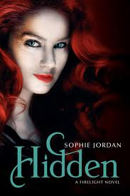

Jordan, S. (2012). Hidden: A firelight novel. New York, NY: HarperCollins Publishers.

This book has mild references to teen romance situations, but I would say that it is appropriate for readers ages 13 and up.

This book is definitely a Fantasy/Paranormal novel.

The third book in a trilogy, this book is about Jacinda, a draki (a creature that is part dragon, part human), and the rescue of one of her own kind that has fallen into the hands of the hunters. Jacinda has also fallen in love with Will, who is in the family of the hunters that get a thrill out of hunting her and her pride out of the skies. In this final installment, the reader learns a lot more about those hunters, who they are and what they want. There is still a conflict between Jacinda and Cassian, who is the heir to the pride and coincidentally, her betrothed. Between the love triangle and a bold rescue mission, the world that Sophie Jordan has created is full of magic and dragon fantasy. Jacinda, her sister and her friends stumble upon a whole world of things they didn’t know existed outside of their pride, and it makes them question everything they’ve ever known.

Themes- Teen romance, family dynamics, dragons , magic

Awards- None to date

My opinion- I hate to be a spoiler, so I’ll do my best not to ruin the entire series for anyone that wants to read it. I’ve been waiting to read this final installment, and so I’m glad I finally had the chance! The book was excellent, even though it was an incredibly fast read and left me wanting more. It’s amazing to re-imagine our world and what it would be like if we had dragons in the world with many different kinds of magical powers, and Sophie Jordan does a good job of making it sexy and alluring. I think most fantasy readers who enjoyed Twilight or Matched would definitely enjoy this seductive fantasy and Jordan’s twist on what a world with dragons would be like.

Ana and the French Kiss by Stephanie Perkins

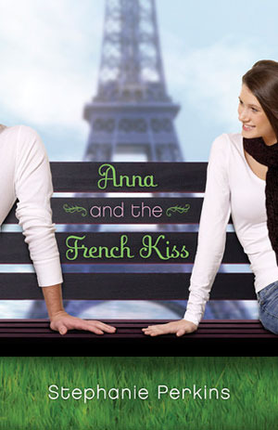

Perkins, S. (2010). Anna and the french kiss. New York, New York : Dutton Books.

Grades 9 and up, ages 14 and up.

Genre: Teen Romance, Contemporary Realistic Fiction

Despite Ana’s plans for her senior year with her best friend, her job, and her crush, Ana is sent off to boarding school in Paris. While Ana definitely isn’t happy about this at first, she eventually settles into Parisian life and makes new friends. One of those friends includes Etienne St. Clair, a boy that Ana definitely has strong feelings for throughout the book. Ana learns a lot about who she is while she’s in Paris, (an aspiring film critic for one) and how sometimes the life people envision for themselves isn’t as great as the life that they can actually have. After facing some challenges with both her new friends and her old friends throughout the book, Ana eventually has to decide what will make her happiest in the end.

Themes: Teen romance, Boarding school, Family dynamics, Paris

Awards:

NPR's Year's Best Teen Reads 2010
NPR's 100 Best-Ever Teen Novels #53
Cybils Award Finalist for Young Adult Fiction 2011
YALSA's Best Fiction for Young Adults 2012 list
YALSA's Popular Paperbacks for Young Adults: Forbidden Romance, 2012

Review:

Perkins does a fantastic job creating a beautiful Paris landscape throughout the novel through Ana’s eyes, and readers will be left wishing for more. Ana is a strong female protagonist that teens will laugh with, cry with, and best of all, want to be friends with. The humor in this novel is just as biting and memorable as Ana herself. Although this novel is about Ana and her love story with Etienne, it is much more about Ana learning who she is and defining herself as a person. This book is a good, clean read that is definitely worth reading. The ending truly feels much more like a beginning, and readers will want Ana’s story to continue on past the last page.

The Duff (Designated Ugly Fat Friend) by Kody Keplinger

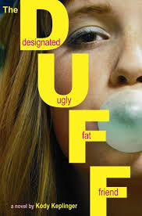

Keplinger, K. (2010). The duff. New York, NY: Poppy.

Grades 10 and up, ages 15 and up.

Genre: Contemporary realistic fiction

In a story that makes every girl re-evaluate their friends and themselves, Bianca Piper takes readers on an emotional ride. Bianca faces her parents’ divorce after the school playboy, Wesley Rush, calls her the DUFF (or Designated Ugly Fat Friend) of her group of friends at a get-together. Although she hates Wesley for the way he treats women and the way he treats her, Bianca finds herself using Wes to get away from her family problems and every other problem in her life. Slowly, but surely, Bianca starts to learn more about Wes and he starts to learn more about her, bringing them closer together until Bianca is horrified to realize that she’s falling for the playboy she has always hated.

Themes: gender stereotypes, friendship dynamics, family problems, teen sex, high school

Awards: None to date

Review:

Although this book is heavy on heavy language and teen intimacy, it does a fantastic job of analyzing issues that teens face today. Bianca is learning how to handle body-image issues and how she defines herself in a high school culture that will gladly label her in hurtful ways. Although Bianca sees her friends as beautiful, smart and far above her, this book does a wonderful job of letting readers know that everyone feels insufficient in one way or another. It artfully (and somewhat painfully) displays the way that family problems can truly damage the children involved, and how teens try to cope with such debilitating problems. The chemistry between Bianca and Wes is fiery, though, and keeps the reader rooting for them to work out up to the end. This book is a gritty but beautifully realistic read, and worth it for every young person to read.
Ender’s Game by Orson Scott Card

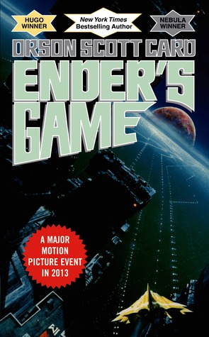

Card, O. S. (1994). Ender's game. New York: Tom Doherty Associates.

Grades 7 and up, ages 13 and up.

Genre: Science Fiction

In a world of two-child families, Ender (Andrew) Wiggin is the third child, born with the hope that he will be the child solider that his elder siblings, Valentine and Peter, could not be. Earth has been attacked, and for the last 100 years, the only way for the government to properly retaliate is to breed and train their own perfect soldiers, meant to attack and destroy the alien race before the aliens have a chance to destroy Earth. When Ender goes to battle school, he is immediately faced with problems and situations that most children there have never dreamed to face. Saddled with the weakest team in the school, adults that wish to see him fail, and the haunting memories of his family and the idea of the alien race, Ender seems doomed to fail. Only time will tell if Ender will save Earth from the aliens once and for all.

Themes: Aliens, war, trust, family relationships, friendship, intelligence

Awards:

Winner of the Hugo Award -1986
Winner of the Nebula Award - 1985
Part of American Library Association’s “100 Best Books for Teens”
Contributed to the winning of the Margaret A. Edwards Award – 2008 (along with Ender’s Shadow)

Review:

Though this read will be difficult for some young readers, it has enough action to keep the pages turning. The age range should realistically be probably be 15 and up, except for advanced readers. The novel is very heavy on the science fiction, but it is entirely from Ender’s head, and so every perspective is skewed to what he thinks and feels. This view often makes Ender a sympathetic character, but in the end, he is a brutal general and warrior. His relationships with his siblings and fellow battle-school peers will leave the reader wanting more, and ultimately, hoping for a happy ending for Ender as well as Earth, but wondering who the real enemy is in the end. It is an excellent read for both young men and women, but a great recommendation for reluctant boy readers.

13 Little Blue Envelopes by Maureen Johnson

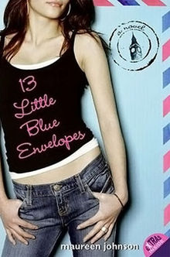

Johnson, M. (2005). 13 little blue envelopes. New York, NY: HarperTeen.

Grades 8 and up, ages 14 and up.

Genre: Mystery, Contemporary Realistic Fiction

When Ginny’s eccentric, artist aunt Peg dies of brain cancer, 17 year-old Ginny receives 13 letters left to her by her aunt. Ginny is left with rules, friends of her aunt and letters to guide her on her way across Europe where she opens a new letter at a new destination. Ginny encounters new adventures at every turn, a budding romance, and even begins to learn more about the aunt that left her the adventure to begin with.

Themes: Family, Travel, Self-discovery, mystery

Awards:
ALA Popular Paperbacks for Young Adults

Review:

This novel is a fast-paced read with beautiful descriptions of the whirlwind tour that Ginny takes of Europe through the letters that she receives from her aunt. The end is left on a cliffhanger when Ginny doesn’t open the last envelope, but it leaves the reader wanting to know exactly what aunt Peg wanted Ginny to know at the very end. Ginny changes a lot over the course of her adventure, though the book does leave the reader wondering about some of the details about Ginny’s parents, about why she’s allowed to travel across Eurorpe alone without any electronics at 17, and the romance between Ginny and Keith lacks spark. Overall, the novel is a quick, fun read, but not an all-engrossing one that truly makes any reader want to read it all over again.

Bright Young Things by Anna Godbersen

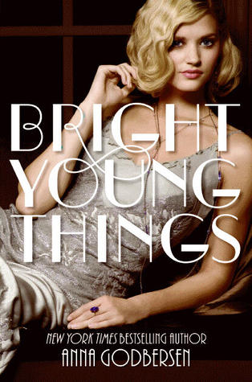

Godbersen, A. (2010). Bright young things. New York, NY: Harper Collins.

Grades 8 and up, ages 14 and up.

Genre: Historical Fiction

The roaring twenties are in full swing, and three young women are ready to experience the glitz and glam of Manhattan in 1929. Letty and Cordelia have fled the Midwest, and Astrid is the inside track to the lifestyle they desperately want to live and enjoy. Between the dangerous parties and speakeasies and the mystery of the men and tracking Cordelia’s father, the New York twenties scene is beautifully lit up and described by Godbersen’s characters and attention to detail. The fast-paced life of the twenties captures each reader and takes them back to an era not to be forgotten.

Themes: Love, mystery, adventure, 1920’s, family

Awards:
None to date

Review:

Simply for the pure beauty in the details of the roaring twenties, this novel is a worthwhile read. Godbersen has a talent for historical fiction, and this book does not disappoint. The story is told by all three girls, alternating perspectives from chapter to chapter as the story moves along, and they each definitely have a different personality and response to the world that they have immersed themselves into. The girls also show that young women have similar qualities in every era, and they are relatable even though modern times can be very different. This book is a very enchanting and addictive read, and a worthwhile recommendation to mature young readers.

Gandhi: A Manga Biography by Kazuki Ebine

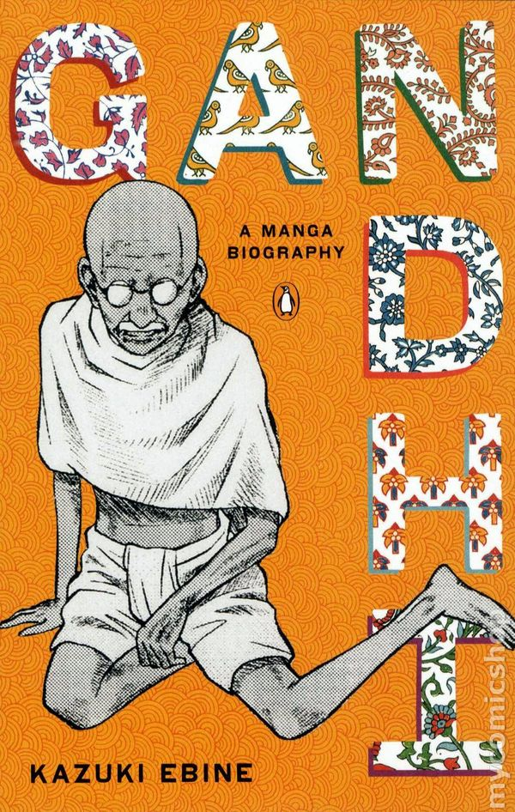

Ebine, K. (2011). Gandhi: A manga biography. New York, NY: Penguin Group.

Grades 7 and up, ages 12 and up.

Genre: Nonfiction, Biography, Graphic Novel

This novel is a new way for young readers to learn about the historical figure of Gandhi. For a man whose name is well-known, this is his story, told in beautiful sketches by Ebine. This is the story of his life from start to end, and it shows many of the struggles that Gandhi not only witnessed, but also endured for himself. He stood up for what he felt was right, and this novel shows his life and influence.

Themes: Friendship, history, Indian culture and people, influence

Awards:
None to date.

Review:

This is definitely an interesting way to tell Gandhi’s story to a new set of readers. If there were many more biographies done in this fashion, children and teens alike would enjoy learning about many different historical figures. The black and white illustrations are simple, but the text is not overbearing with information and yet very factual and informative. The narrative itself is not altogether captivating, but it is a quick read that is innovative and educational at the same time.

